
User Manual

LED ELLIPSOIDAL LIGHT

ST PROFILE500RGBAL

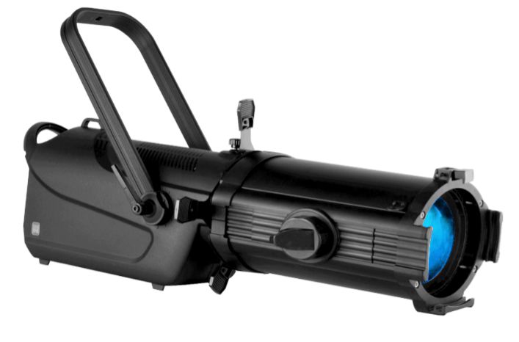
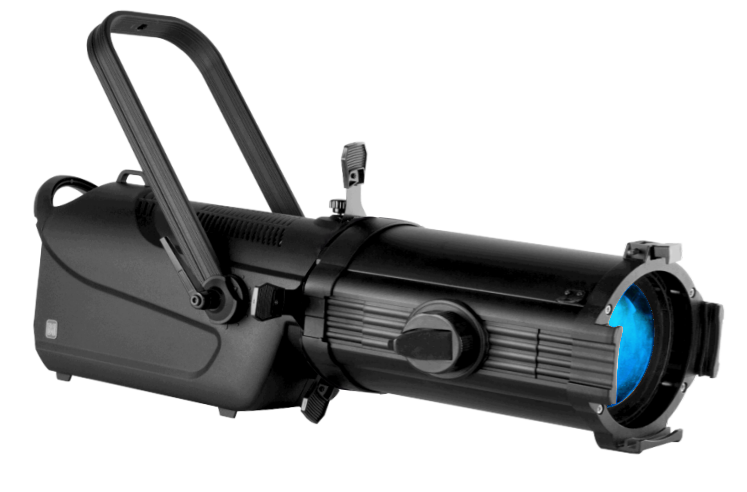

CONTENT
1. safety warning 3
2.technology parameters 4
Electronic parameters 4
Opitical parameter 4
Mechanical environmental parameter 4
3.Dimensional Drawing 5
4.Illumination Chart 9
5. Installation 12
Installation and method 10
power connection 14
connect DMX512 console setting 14
6.operation method 16
keys operation 13
manual setting 16
system setting 16
7.Fixture Address 17
8. System information 17
9. Control Channel Table 18

Safety Warning
Please read this manual carefully, it includes important information such as installation, use and maintenance.

- Before using,please open it and check carefully to ensure that there is no damage caused by transportation.
- Make sure that the grounding is normal before using.
- Make sure that the device is used within the voltage specification range identified.
- This lamp is only suitable for indoor dry place.
- Please avoid collision with hard things in installing, using and moving.
- The fixture temperature is high in working, Please keep safe distance with combustible material.
- There are no parts in the fixture that could be used by users. Non-professionals are not allowed to open the shell or repair the fixture, Please contact the manufacturer or agent when it needs repair.
- The fixture shall be installed and maintained by qualified electronic technicians.
- The user must comply with the safety provisions and precautions in the manual.
- The manufacturer shall not be responsible for any accident or loss caused by any failure to operate and use the fixture in accordance with this manual or to change it without permission.

Technology parameters

Electronic parameters
Input voltage:100-240Vac 50/60Hz
Power:300W
Control mode:DMX512
Control channel:7/17 CH
DMX input/output interface: XLR 3/5PIN
Power port:Aviation head

Opitical parameter
Light source:500W COB Light
Color (Light source): Red Green Blue Amber Lime
Color Temperature:2700K~6500K adjustable
Color Rendering Index:≥90
Beam Angle:5°、10°、14°、19°、26°、36°、50°optional
15°-30°adjustable
Lumen:19000LM
Dimmer:0-100%
Strobe:0-20Hz

Mechanical and physical parameters
Case Material:Die-casting aluminum/aluminum/Plastic
Protection Grade:IP220
Working Temperature:-20~40°C
Noise:＜40db
Net Weight:11.5KG
Dimension:
1187*361*560mm（5°）
887*296*525mm（10°）
837*285*525mm（14°）
768*285*525mm（19°、26°、36°、50°）

3.Dimensional Drawing
Fixture size with 5°lens (1187*361*560mm)
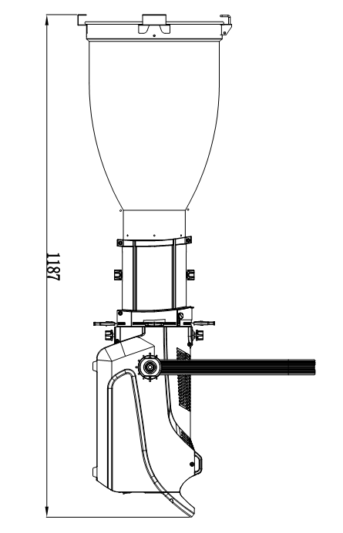
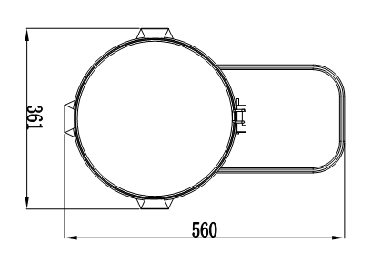

Fixture size with 10°lens (887*296*525mm)
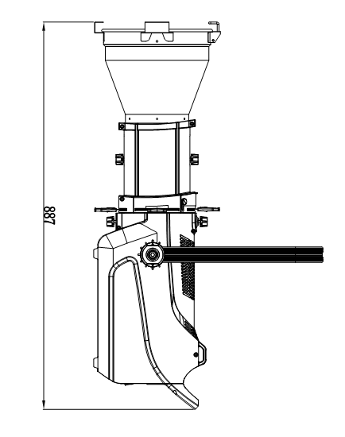
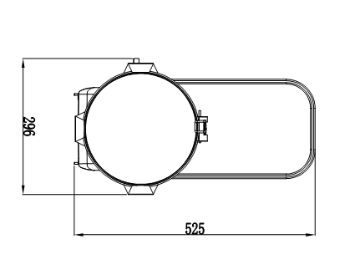

Fixture size with 14°lens (837*285*525mm)
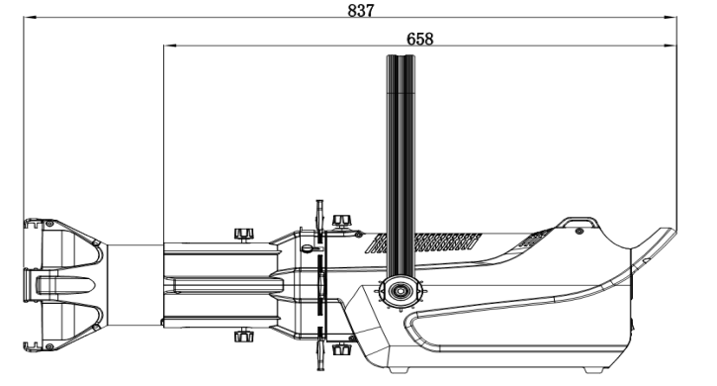
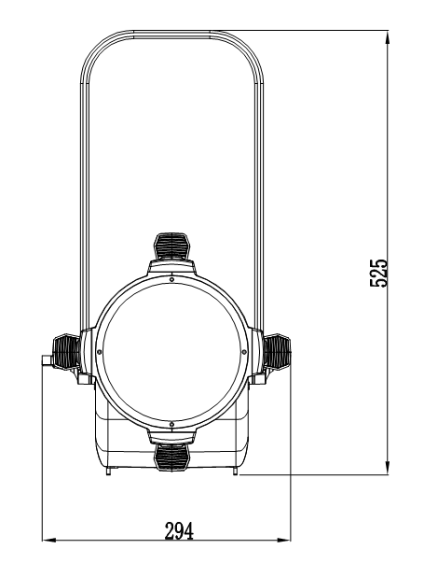
Fixture size with 19°、26°、36°lens769*285*525mm
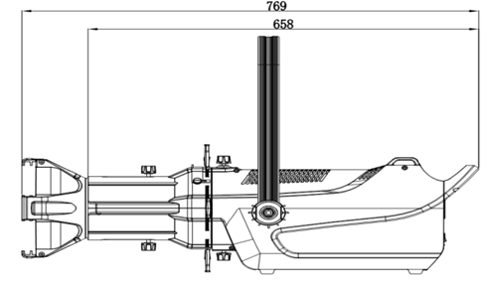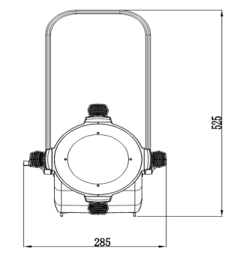

Fixture size with 15-30°Lens 917*294*525mm

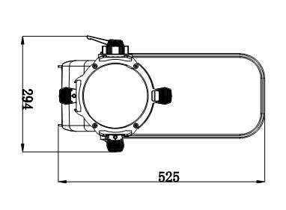
*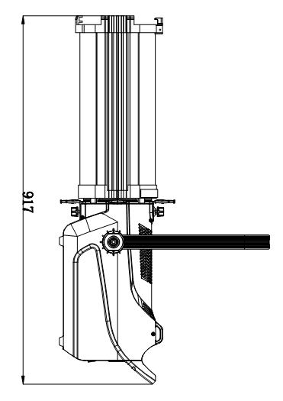

4.Illumination Chart
5°lens Illumination Chart
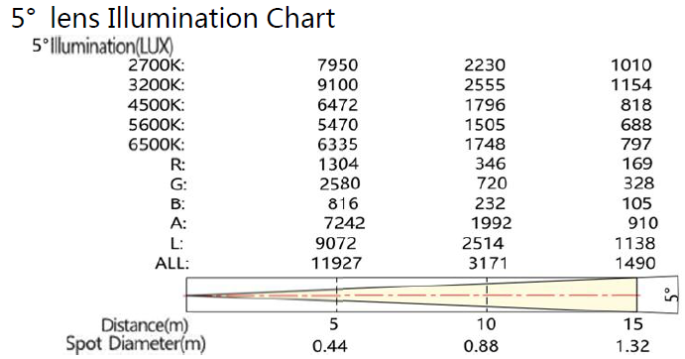

10°lens Illumination Chart
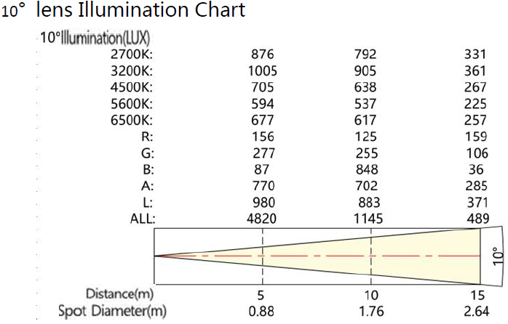
14°lens Illumination Chart
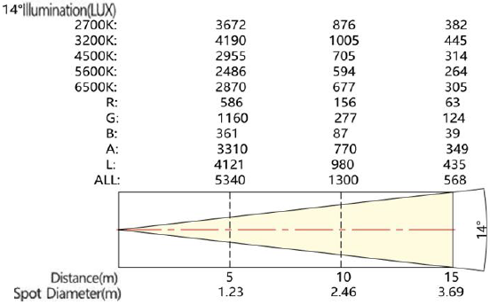
19°lens Illumination Chart
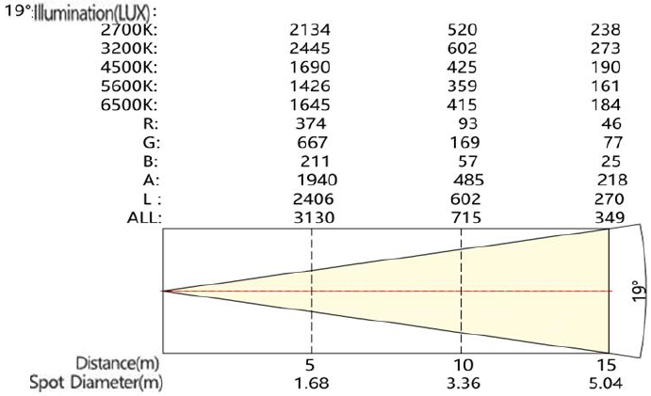

26°lens Illumination Chart
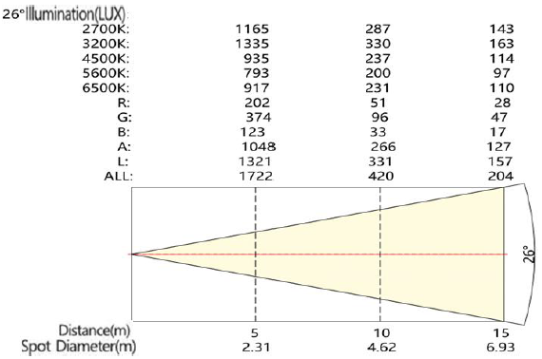
36°lens Illumination Chart
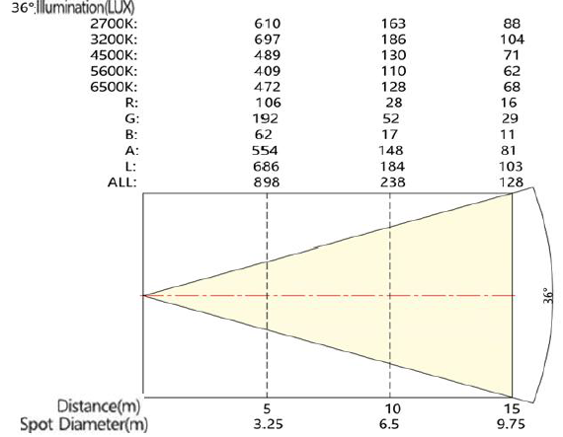
15-30°lens Illumination Chart
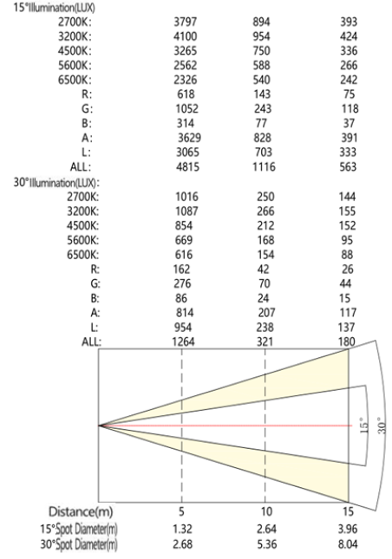

5. Installation

5.1 Installation and Method
Horizontal place:
▲ Hanging handle can adjust Angle , in order to install the right lamp bracket , as shown in the figure below.

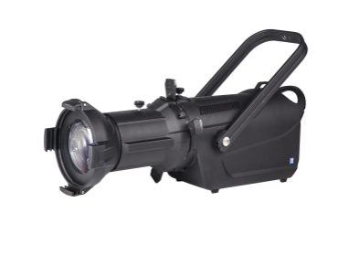
Hanging handle

Hanging place:
Notice: ensure the installation position is completely suitable for this product, to ensure safe and reliable installation location ;
▲ Use and install the equipment , must be far away from flammable items, to ensure to keep a distance of 0.3 meters and flammable materials ;
▲ Use the right tools to fix the lighting equipment in the proper installation location ;
▲ Device of install lamps must be able to withstand the weight of more than ten times of lamps itself, and ensure the suspension location with no obvious deformation within an hour ;
▲ Use rope to hang the lamps , the rope used must be able to sustain the weight of more than ten times of lamps itself. And insure rope must with safety class .;Approach is to build the insurance rope around fixtures are handle or other fixed objects , after the insurance rope end plug tight buckle and the screw , as shown in the figure below.
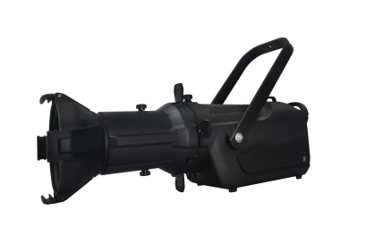
Safety rope round the back handle
Horizontal place:
▲Lens install as shown in the figure below：
1. Arrow and knob aligned in a straight line;
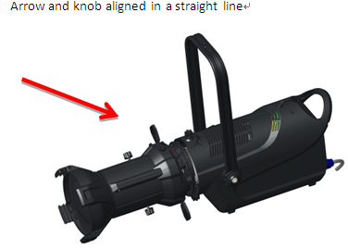
2. Put lens cone to the box and rotate clockwise；
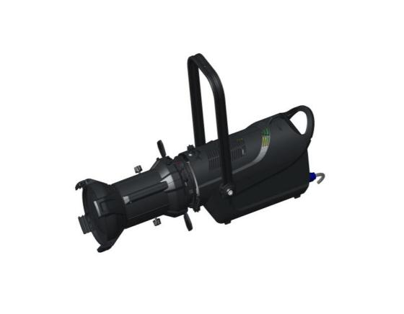
Clockwise rotation

顺时针旋转
3. Clockwise to stop after the knob on the lens cone and keep in the same line, and makes the knob body fasten.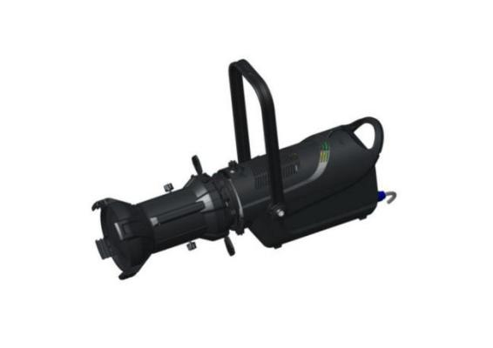
Fastening knob

5.2 Power connection
- Power cable uses 2.5 mm2 copper cores. Power in series, the 220V AC power is no more than 8 lamps; Using a 110V AC power can’t more than 4 lamps;
- DMX512 signal cable connect 20pcs fixtures Max; When the distance between console and fixture, or distance between two fixtures, longer than 50M then add a signal amplifier is very necessary;
- Recommend to plug a terminal in signal output socket of the last fixture, which connected in the end of each signal transmission line. To weld a 120Ω / 1W resistor between the male plug 2 and 3 feet to make a terminal plug. The usage is to reduce the reflected wave interference caused by the end of control signal cable's circuit open.

5.3 DMX512 Console Connect
- Serial connect the DMX512 console and signal cable.
- DMX512 address code is reusable.
- DMX512 address code can be any number between 001 to 512.
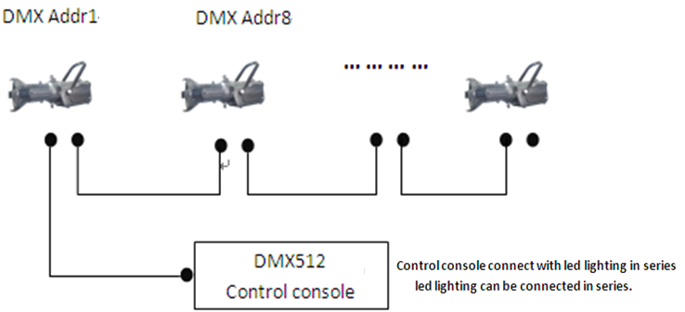
Series connection the console with lighting，Series connection the lighting with lighting (console)

6.Operation

6.1 Key operation
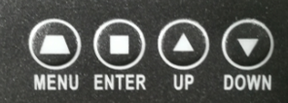
■ ENTER:Go to the next level of function submenu and save or confirm the setting function data.
■ UP :Select the function submenu and cycle up the data
■ DOWN :Select the function submenu to cycle down the data
■ MENU :Go back to the previous menu and turn off
or power on.

6.2 Menu Settings

System setting
Item | Value
Running mode | DMX、M/S、
Channel | Standard 、Reduced
Program | None、Prog1、Prog2、Prog3
Language | Chinese、English
Screen | Normal、Inverted
Sighold | ON、OFF（Maintain the final control state when the signal is disconnected）
Dimcurve | Linear、Square、I-Square、S-Shape
Dimspeed | Tungsten 、Ledmode
Dimmode | HiRate、Smooth(Signal refresh rate)
NRF Addr | Set the wireless control address (suitable for assembling wireless functional lamps)
◇ Press [ENTER] in the [CTRL] menu to enter the manual setting;
◇ Press [UP]or [DOWN] to choose the channel;
◇ Press [ENTER] to enter the channel data;
◇ Press［UP］or［DOWN］to change the data ;
◇ Repeat 2-5 to modify the other data channels;
◇The functional layout of data channel is shown in [Control Channel Table].

6.3 DMX mode
1.Confirm[System Set}--[Operational Mode] change to DMX mode; and close the set program;
2.Confirm DMX connection is correct;
3.Confirm the fixture address is correct;
4. When using the lamp base, confirm the channel mode is the same with the lamp base.

6.4 M/S Mode
1.Cut down the connection of fixture and DMX console;
2.Confirm the only one main fixture on the link;
3.Confirm the main fixture [System set]-[Operational mode] change to [M/S] mode;
4.[M/S] mode only support this series products;
5.[M/S] mode , the fixture quantity is no more than 12 pcs.

7. Fixture Address

1.[Menu]--[Fixture Address]

2.Correct the address by [up] and [down]
3.Press [Menu] to save and quit.

8.System information
1.Press [System Information]
2.the temperature of led board, cumulative running time, version, and RDM-UID will on it.
3.Press [Menu] quit.

9.Control Channel Table
Channel Mode |  | Channel Name | Value | Function
Reduced | Standard | Channel Name | Value | Function
1 | 1 | Hue | 000-255 | 360° Hue set
2 | 2 | Hue_fine | 000-255 | Fine tone
3 | 3 | Saturation: | 000-255 | Saturation: 0-100%
4 | 4 | Dimmer intensity : | 000-255 | Dimmer: 0-100%
5 | 5 | Dimmer intensity fine | 000-255 | Dimmer Fine;
6 | 6 | CCT | 000-255 | CCT: 2700K-6500K
7 | 7 | Strobe: | 000-002 | Normally
7 | 7 | Strobe: | 003-127 | Strobe 0-20Hz
7 | 7 | Strobe: | 128-252 | Random strobe
7 | 7 | Strobe: | 253-255 | Normally
\ | 9 | Ctrl_onff | 000-004 | 10-14 Color switch off
\ | 9 | Ctrl_onff | 005-250 | Activate the palette or use white light  Color tuning can be added
\ | 9 | Ctrl_onff | 251-255 | 10-14 Color switch on
\ | 10 | Red | 000-255 | Red Brightness 0-100%
\ | 11 | Green | 000-255 | Green Brightness 0-100%
\ | 12 | Blue | 000-255 | Blue Brightness 0-100%
\ | 13 | Amber | 000-255 | Amber Brightness 0-100%
\ | 14 | Lime | 000-255 | Lime Brightness0-100%
\ | 15 | Dimmer curve | 000-063 | Linear dimming curve
\ | 15 | Dimmer curve | 064-127 | Square dimmer curve
\ | 15 | Dimmer curve | 128-191 | Inverse square dimmer curve
\ | 15 | Dimmer curve | 191-255 | S-shaped dimming curve
\ | 16 | Dimmer speed | 000-127 | Dimming effect of tungsten lamp
\ | 16 | Dimmer speed | 128-255 | Dimming effect of LED lamp
\ | 17 | Fan | 000-127 | automatic control
\ | 17 | Fan | 128-255 | manual control
Note:
1.Priority: Toning switch9 ＞Saturability 3 ＞Color Temperature 6
2.Clockwise adjust the hue by 5°to activate HSI function.
Power cable | 1pcs | Signal cable | 1 pcs
Safety rope | 1 pcs | Manual | 1 pcs
Color paper clip | 1 pcs | Pattern holder | 1 pcs

